

Technical Assignment Prospective DevOps

provider "azurerm" {
version = "=1.28.0"
}

resource "azurerm_resource_group" "test" {
name = "production"
location = "West US"
}

resource "azurerm_storage_account" "testsa" {
name = "${var.storageAccountName}"
resource_group_name = "${azurerm_resource_group.testrg.name}"
location = "${var.region}"
account_tier = "${var.tier}"
account_replication_type = "${var.replicationType}"

}
# Create virtual machine
resource "azurerm_linux_virtual_machine" "myterraformvm" {
name = "myVM"
location = "eastus"
resource_group_name = azurerm_resource_group.myterraformgroup.name
network_interface_ids = [azurerm_network_interface.myterraformnic.id]
size = "Standard_DS1_v2"

os_disk {
name = "myOsDisk"
caching = "ReadWrite"
storage_account_type = "Premium_LRS"
}

from flask import Flask, render_template

app = Flask(__name__)

@app.route('/')
def index():
return render_template('index.html')

/etc/init.d/cleantmp
#!/bin/sh
### BEGIN INIT INFO
# Provides: cleantmp
# Required-Start:
# Required-Stop: $local_fs
# Default-Start:
# Default-Stop: 0 1 6
# Short-Description: clean temporary folders
# Description:
### END INIT INFO

PATH=/sbin:/usr/sbin:/bin:/usr/bin

echo "Clean up temporary folders"
rm -rf /home/user/tmp/*
Then I gave it the execution rights:
$ sudo chmod +x /etc/init.d/cleantmp
$ ls -l /etc/init.d/cleantmp
-rwxr-xr-x 1 root root 329 Dec 19 12:50 /etc/init.d/cleantmp
Then I update the rc:
$ sudo update-rc.d cleantmp defaults
$ ls -l /etc/rc?.d/*cleantmp
lrwxrwxrwx 1 root root 18 Dec 19 13:12 /etc/rc0.d/K01cleantmp -> ../init.d/cleantmp
lrwxrwxrwx 1 root root 18 Dec 19 13:12 /etc/rc1.d/K01cleantmp -> ../init.d/cleantmp
lrwxrwxrwx 1 root root 18 Dec 19 13:12 /etc/rc6.d/K01cleantmp -> ../init.d/cleantmp

Route.add(‘/api/v1/healthcheck’, Method=’GET’) {
If (userdb.connect() == “Successful”) {
headers={‘http_status’:200, ‘cache-control’: ‘no-cache’}
body={‘status’: ‘available’}
}
Elseif (backupdb.connect() == “Successful”) {
headers={‘http_status’:203, ‘cache-control’: ‘no-cache’}
body={‘status’: ‘backup-storage available’}

}
Else {
headers={‘http_status’:500, ‘cache-control’: ‘no-cache’}
body={‘status’: ‘unavailable’}
}
}

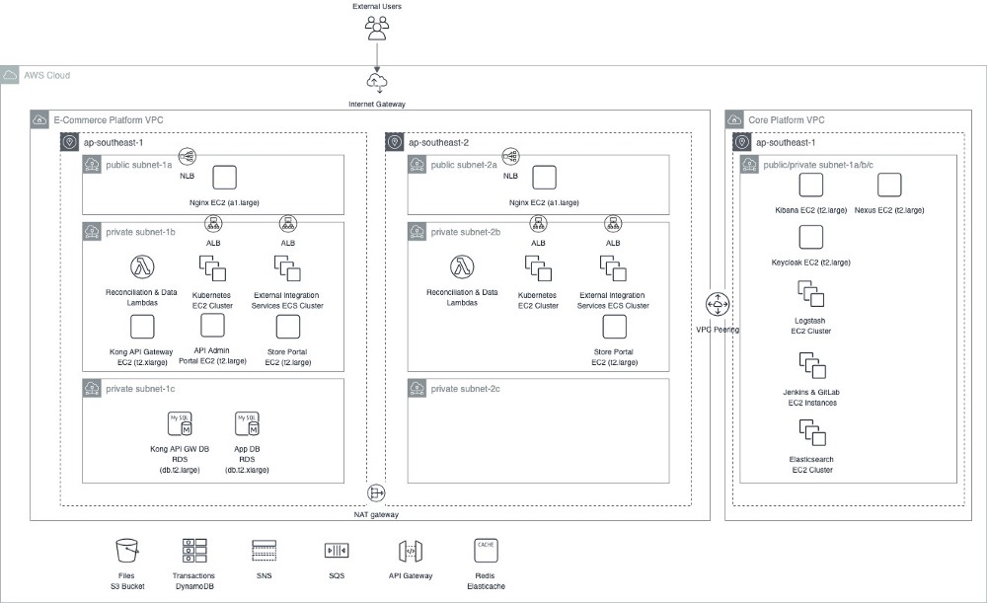

The install script will install Debian on a user-prompted block device. Supports installations on hardware using UEFI or legacy BIOS and will set a GPT partition table and ext4 filesystem. Other features, such as bootloader or encryption, are set when prompted.
The OS can be configured for LVM-on-LUKS full-disk encryption or not. Using GRUB will also encrypt the /boot directory and write a decryption key into the initial ramdisk so that the password prompt only appears once. For alternate bootloaders, the boot directory will remain unencrypted.
There is also the optional provision for creating a separate, unencrypted partition of arbitrary size. Useful for creating shared filesystems readable on Windows / MacOS for USB drive installations.
The rough partition scheme is:
1. BIOS compatibility parition, empty if GRUB not used (1 Mb)
2. EFI partition (500 Mb)
3. Share partition (optional)
4. Debian system (Plain / LVM / LUKS-encrypted partitions or volumes)
- swap
- root
- home (optional)
Note: The script uses sgdisk for partitioning, which uses binary (base 2) units for specifying partition sizes. For example, 500M corresponds to 500 mebibytes, not 500 megabytes.
To run, (need to be root):
sudo ./install

Options
Installation options will be queries as the script runs.

Partitioning
1) Back
2) LVM on LUKS
3) LVM
4) Plain
- Installs on LUKS-encrypted partition. Partitions (e.g. root and home) are kept as logical volumes on the LUKS partition.
- Installs on unencrypted LVM partition.
- Installs everything on primary partitions.

Boot system
1) Back
2) GRUB
3) systemd-boot
4) EFISTUB
- Installs GRUB, BIOS version of no EFI firmware is detected. Otherwise, the EFI version is installed.
- systemd-boot (previously gummiboot) installs kernels in /boot and copies them over to /efi. Systemd path hoods are also installed to update kernel images and microcode in /efi after updates.
- Not supported yet...

Etc.
The script will also prompt for:
- Host name
- User name
- User password
- (Optional) LUKS password
- Locale (e.g. en_US.UTF-8)
- Time zone (e.g. America/Toronto)
The script will then mount the partitions, set up chroot, download and install all the base and base-devel packages via debootstrap, set up the specified user account, lock the root account, and unmount everything.

Post-install
Once the base system is installed, use the ./postinstall script (as the user account, not root), to install the remaining packages, themes, etc.
Simply run:
./postinstall

Connect to your instance
- In the Cloud Console, go to the VM instances page.
Go to VM instances
- In the list of virtual machine instances, click SSH in the row of the instance that you want to connect to.
You now have a terminal window for interacting with your Linux instance.
For details, see the Quickstart using a Linux VM.

Step 3: Run a basic Apache web server

Install Apache
- From the SSH window, use the Debian package manager to install the apache2 package.
- sudo apt-get update && sudo apt-get install apache2 -y
After installing Apache, the operating system automatically starts the Apache server.
- Overwrite the default web page for the Apache web server by using the following command:
- echo '<!doctype html><html><body><h1>Hello World!</h1></body></html>'\
| sudo tee /var/www/html/index.html

Test your server
Test that your instance is serving traffic on its external IP address.
- In the Cloud Console, go to the VM instances page.
Go to VM instances
- In the External IP column, copy the external IP address for your instance.
- In a browser, navigate to http://[EXTERNAL_IP]. Do not use https to connect because the server will return a Connection Refused error.
You should now see the Hello World! page.
For further details, see Running a basic Apache web server.

Step 4: Set up your domain using Cloud DNS
If you are migrating from an existing provider, you can import your existing zones to Cloud DNS. For instructions, see Export your DNS configuration from your existing provider. Otherwise, follow these steps to create a new public zone.
- In the Cloud Console, go to the Create a DNS zone page.
Go to Create a DNS zone
- For the Zone type, select Public.
- For the Zone name, enter my-new-zone.
- For the DNS name, enter a DNS name suffix for the zone by using a domain name that you registered (for example, example.com).
- For DNSSEC, ensure that the Off setting is selected.
- Click Create to create a zone populated with the NS and SOA records.
- To point your registered domain name to the IP address of the hosting server, you must add an A record to your zone:
  - On the Zone details page, click Add record set.
  - Select A from the Resource Record Type menu.
  - For IPv4 Address, enter the external IP address for your instance.
  - Click Create to create the A record for your zone.
- Optional: Add a CNAME record to account for a prefix to your domain name (for example, www.):
  - Click Add Record Set.
  - In the DNS Name field, add the prefix www for the domain.
  - For Resource Record Type, choose CNAME.
  - For Canonical name, enter the domain name, followed by a period (for example, example.com.).
  - Click Create.
- On the Zone details page, click Registrar Setup on the top right to access the NS records. Make a note of the NS records because you need these records to proceed with Step 5.
Note: If you want to set up SMTP servers for delivering email to your domain, you must add MX records to your zone. For instructions about setting up MX records if you are using Google Workspace, see the Set up MX records support page. If you are using a different SMTP provider, use the MX record details from your provider and follow the same instructions.

Step 5: Update name servers
To update name servers in Google Domains, follow these steps:
- To update the name servers for your domain, go to Google Domains.
- Click the domain that you set up in Step 1. Alternatively, you can click the Manage link for that domain.
- On the left navigation menu, click DNS.
- For Name servers, select Use custom name servers.
- In the Name server field, enter the NS records that you copied from the Zone details page (for example, ns1.googledomains.com) one at a time.
- To add name servers, click addAdd.
- Update all four name servers on your Google Domains DNS page.
- Click Save.
Note: Enter the authoritative name servers for Cloud DNS in the name servers section of Google Domains, as opposed to adding them as NS records to the Google Domains managed zone.Note: The name server update can take from 48 to 72 hours to propagate.

Step 6: Verify your setup
To verify that your configuration is working, after the name servers are updated, navigate to your domain name (for example, example.com). The domain should resolve to your IP address and should point to the Compute Engine VM displaying the Hello World! page that you created in Step 3.
To verify that your setup is correct, you can also run the dig +trace example.com command on your terminal window. Replace example.com with your registered domain name.
dig +trace example.com
The end of the output should include the following. IP_ADDRESS is your web server's IP address.
example.com. 300 IN A IP_ADDRESS
;; Received 62 bytes from 216.239.34.109#53(ns-cloud-d2.googledomains.com) in 62 ms
Note: If you're using Microsoft Windows and dig is not installed on your system, you can run a dig -t NS query from the Google Workspace web interface.
To verify that the changes were successful, the following line in your command output shows that the top-level domain name servers are pointing to the custom name servers that you entered in Google Domains, as opposed to the original name servers provided by Google Domains:
example.com IN NS <your Cloud DNS name servers>
After waiting for DNS propagation to complete, you can also run the nslookup command to verify your setup:
nslookup example.com
The output should include the following. IP_ADDRESS is your web server's IP address.

Server: 127.0.0.1
Address: 127.0.0.1#53

Non-authoritative answer:
Name: example.com
Address: IP_ADDRESS

Clean up
Note: To avoid incurring charges for the resources that you created, you can delete them by following the instructions in this section. However, if you use Cloud Domains to register a domain, you might continue to be billed for the domain. For details, see the Cloud Domains pricing page.
- In the Cloud Console, go to the Cloud DNS zones page.
Go to Cloud DNS zones
- Click a zone name (for example, my-new-zone) to get to the Zone details page.
- Select the A and CNAME records that you created.
- Click Delete record sets.
- To delete the zone, click deleteDelete zone for the zone name my-new-zone.
- Go to the VM instances page.
Go to VM instances
- Select the instance that you want to delete.
- On the more_vertMore menu in the row of the instance, click Delete.

Create Your Node Application
Now, create a directory for your node application. You can do that with the following commands:
mkdir todolist
cd todolist
Use npm init to go through a wizard that will prompt up for various configuration details, including the entry point, author, name, and test scripts. Skip these questions and use the default fields by using npm init -y.
Now that Node has been initialized on your directory you can start framing out your project structure.
First, create folders for config, repository, routes, server, and views.
In the config folder, you will create a general configuration file named config.js and a specific one for index.js that will serve as your entry point.
In the repository folder, create a file named todoitems_repository.js. This will serve as the access layer to your Postgres database.
For routes you will have two routes; items.js and users.js. items.js will contain the routing logic for your list and creation of new items. users.js will contain the routes you need to present the user with a login page. Note, you won’t need login functionality, as that will be handled by the Okta middleware.
In the Server folder, create a server.js file to contain your server logic that register middleware, instantiate your routes, and handle any unhandled errors for your server.
Finally, add 5 views: create.pug, error.pug, home.pug, layout.pug, and login.pug. The layout.pug file provides a template for each page and provides common page functionalities like headers and footers. The home.pug file will be your dashboard page that displays the list of incomplete items to the user. The file create.pug provides your user a place to create a new item. The login.pug file gives unauthenticated users a landing page and provides a link to your Okta login page, and the error.pug file displays a generic error page if your server encountered an unexpected hiccup.
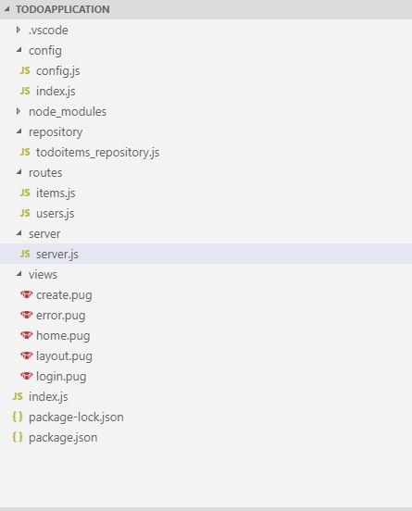

Register Your Node Dependencies
For this project, you’ll use a handful of dependencies from the Node Package Manager via the following terminal commands.
First, you need to add express.js and to help handle session parameters, you will also want to get Express Session:
npm install express@4.14.0
npm install express-session@1.17.0
For your ORM, Sequelize is one of the easiest and most powerful options available on Node. In addition to Sequelize, you will also need the pg package, which handles Postgres:
npm install sequelize@5.19.3
npm install pg@7.12.1
Of course, to make it even easier to interface with Okta, add our OIDC middleware, as well as the Okta Node SDK:
npm install @okta/oidc-middleware@2.0.0
npm install @okta/okta-sdk-nodejs@2.0.1
To render your views, add the Pug view engine:
npm install pug@2.0.4
Finally, two utility packages, http-status and body-parser provide properties for HTTP Status Codes and convert the form data or JSON to javascript objects.
npm install body-parser@1.19.0
npm install http-status@0.2.5

Connect the Node Application to the Postgres Database
Let’s now connect your application to your database. In todoitems_repository.js, start a new instance of Sequelize. First, create a function called initSequelize and add your initialization logic there:
var sequelize = new Sequelize(config.database, config.user, config.password, {
host: config.server,
dialect: 'postgres',
define: {
freezeTableName: true,
timestamps: false
}
});
You’ll notice you set freezeTableName to true. This offers greater control over how Sequelize names the models in your code. The dialect property tells Sequelize that it is using Postgres.
Next, define your Item model from the database in your Node application. At the top of your todoitems_repository.js file, under the sequelize declaration, create a ToDoItem class that extends a Sequelize.Model:
class ToDoItem extends Sequelize.Model {}
Back in your initSequelize function, add the full model definition for ToDoItem:
ToDoItem.init(
{
id: {
type: Sequelize.INTEGER,
allowNull: false,
primaryKey: true,
autoIncrement: true
},
title: {
type: Sequelize.STRING,
allowNull: false
},
description: {
type: Sequelize.STRING,
allowNull: false
},
iscomplete: {
type: Sequelize.BOOLEAN,
allowNull: false
}
},
{
sequelize,
tableName: 'Item'
}
);
Once you have Sequelize set up, you can implement a repository function to utilize Sequelize to perform database operations. he javascript Object.create method will declare the exposed functions:
const repository = function(config) {
var sequelize = initSequelize(config);
Object.create({
disconnect,
createToDoItem,
getAllIncompleteToDoItems,
markAsComplete
});
};
Of course, you can’t use these functions unless they are defined, so let’s modify the repository function to implement these methods using Sequelize. It should look like this:
const repository = function(config) {
var sequelize = initSequelize(config);

const disconnect = function() {
sequelize.close();
};

const createToDoItem = function(title, description) {
return ToDoItem.create({
title: title,
description: description,
iscomplete: false
});
};

const markAsComplete = function(id) {
return ToDoItem.update(
{
iscomplete: true
},
{
where: {
id: id
}
}
);
};

const getAllIncompleteToDoItems = function() {
return ToDoItem.findAll({
where: {
iscomplete: false
}
});
};

return Object.create({
disconnect,
createToDoItem,
getAllIncompleteToDoItems,
markAsComplete
});
};
The function above provides you with common methods that modify your ToDoItems, such as update, create, delete, and findAll. Sequelize functions take objects that can carry information for your where select options, your update options, and your where clauses.
Importantly, this function will not return a list of ToDoItems, as it might appear. Sequelize is promise-based, and therefore this function will return a promise. IYou will need to allow the promise to resolve in your service layer to retrieve your true list of ToDoItems.

Set up Routes
In your two routes files (users.js, items.js) you will set up the actions the client can take against the server.
You start with the simpler users route and set up two separate actions, one for logging out and one for serving your login page to an unauthenticated user. Because Okta handles the login process for us, you don’t need to worry about that part.
app.get(basepath + '/logout', (request, response, next) => {
request.logout();
response.redirect('/');
});

app.get(basepath + '/index', (request, response, next) => {
if (!request.userContext) {
return response.render('login');
} else {
return response.redirect('/');
}
});
This simply checks if the user is already logged in. If they are not, it shows the user the login page. Otherwise, it allows the user to move on to the home page.
The home page and server calls to manage your items will be controlled by the items routes. Below you can see the routes set up for the calls you will need.
app.get(basepath, ensureAuthenticated, function(request, response) {
repo
.getAllIncompleteToDoItems()
.then(items => {
response.render('home', {
user: request.userContext.userinfo,
items: items
});
})
.catch(err => {
response.render('error');
});
});

app.get(basepath + '/create', ensureAuthenticated, function(request, response) {
response.render('create');
});

app.post(basepath + '/items/create', ensureAuthenticated, function(
request,
response
) {
repo
.createToDoItem(request.body.title, request.body.description)
.then(data => {
response.redirect('/');
})
.catch(err => {
response.render('error');
});
});

app.post(basepath + '/items/complete', ensureAuthenticated, function(
request,
response
) {
repo
.markAsComplete(request.body.id)
.then(data => {
response.redirect('/');
})
.catch(err => {
response.render('error');
});
});

function ensureAuthenticated(request, response, next) {
if (!request.userContext) {
return response.status(401).redirect('../users/index');
}

next();
}
This registers two routes for the two pages that items will serve; create and home, and set up two post methods. One creates any new items a user inputs, while the other lets the user mark an item as complete.
As I mentioned before, Sequelize is promise-based. When you call getAllIncompleteItems, it returns a promise. By calling then on the promise, it is allowed to resolve and hook into the result (a list of items) in the callback function. In this case, part of the model that home.pug uses to render the content supplies the items.
Also,the ensureAuthenticated() function is passed in as a route handler and evaluated before the request is handled. ensureAuthenticated() asks if the user is authenticated, like your login page (but backward). If they are not, it redirect them back to the login page from your users route with a standard 401 status.

Build the Node Server
Next, register your middleware and take care of any error handling in a server.js file away from your entry point.
Register Pug as your view engine and set up body-parser to look for form data coming from the client:
app.set('view engine', 'pug');
app.use(bodyParser.urlencoded({ extended: false }));
body-parser also has built-in functionality for JSON if you want to post from javascript on the client, but it’s not necessary for this simple project.
Next, register routes in the application. To do this, inject the application into the route managers and any objects you need. For example, the items route will need access to your repository, while the users routes do not.
items(app, options);
users(app, null);
Finally, you can start your server:
const server = app.listen(options.port, function() {
resolve(server);
});
Notice you injected the options from your entry point, which you will see shortly.
Your start function in the server.js file should look like below:
const start = function(options) {
return new Promise(function(resolve, reject) {
process.on('unhandledRejection', (reason, p) => {
console.log('Unhandled Rejection at: Promise', p, 'reason:', reason);
});

if (!options.port) {
reject(new Error('no port specified'));
}

if (!options.repo) {
reject(new Error('no repo'));
}

const app = express();

app.set('views', path.join(__dirname, '../views'));
app.set('view engine', 'pug');

app.use(bodyParser.urlencoded({ extended: false }));

app.use(function(error, request, response, next) {
reject(new Error('something went wrong' + error));
response.status(500).send('something went wrong');
});

const oidc = new ExpressOIDC({
issuer: options.okta.url + '/oauth2/default',
client_id: options.okta.clientId,
client_secret: options.okta.clientSecret,
appBaseUrl: options.okta.appBaseUrl,
scope: 'openid profile',
routes: {
login: {
path: '/users/login'
},
callback: {
path: '/authorization-code/callback',
defaultRedirect: '/'
}
}
});

app.use(
session({
secret: '{some really long random string}',
resave: true,
saveUninitialized: false
})
);

app.use(oidc.router);

items(app, options);
users(app, null);

const server = app.listen(options.port, function() {
resolve(server);
});
});
};

